**KNN**

**Glass Classification Solution**

* I have split the data in 70-30 ratio.
* By creating the function for finding the best K, I was able to find that the best value for K here would be 3.
* For k=3, Training accuracy = 82.5%. Testing Accuracy = 63.07%
* In this problem, the amount of data for the model to learn is less compared to the categories. That’s why we are getting less accuracy.
* Following is the graph for different k values:

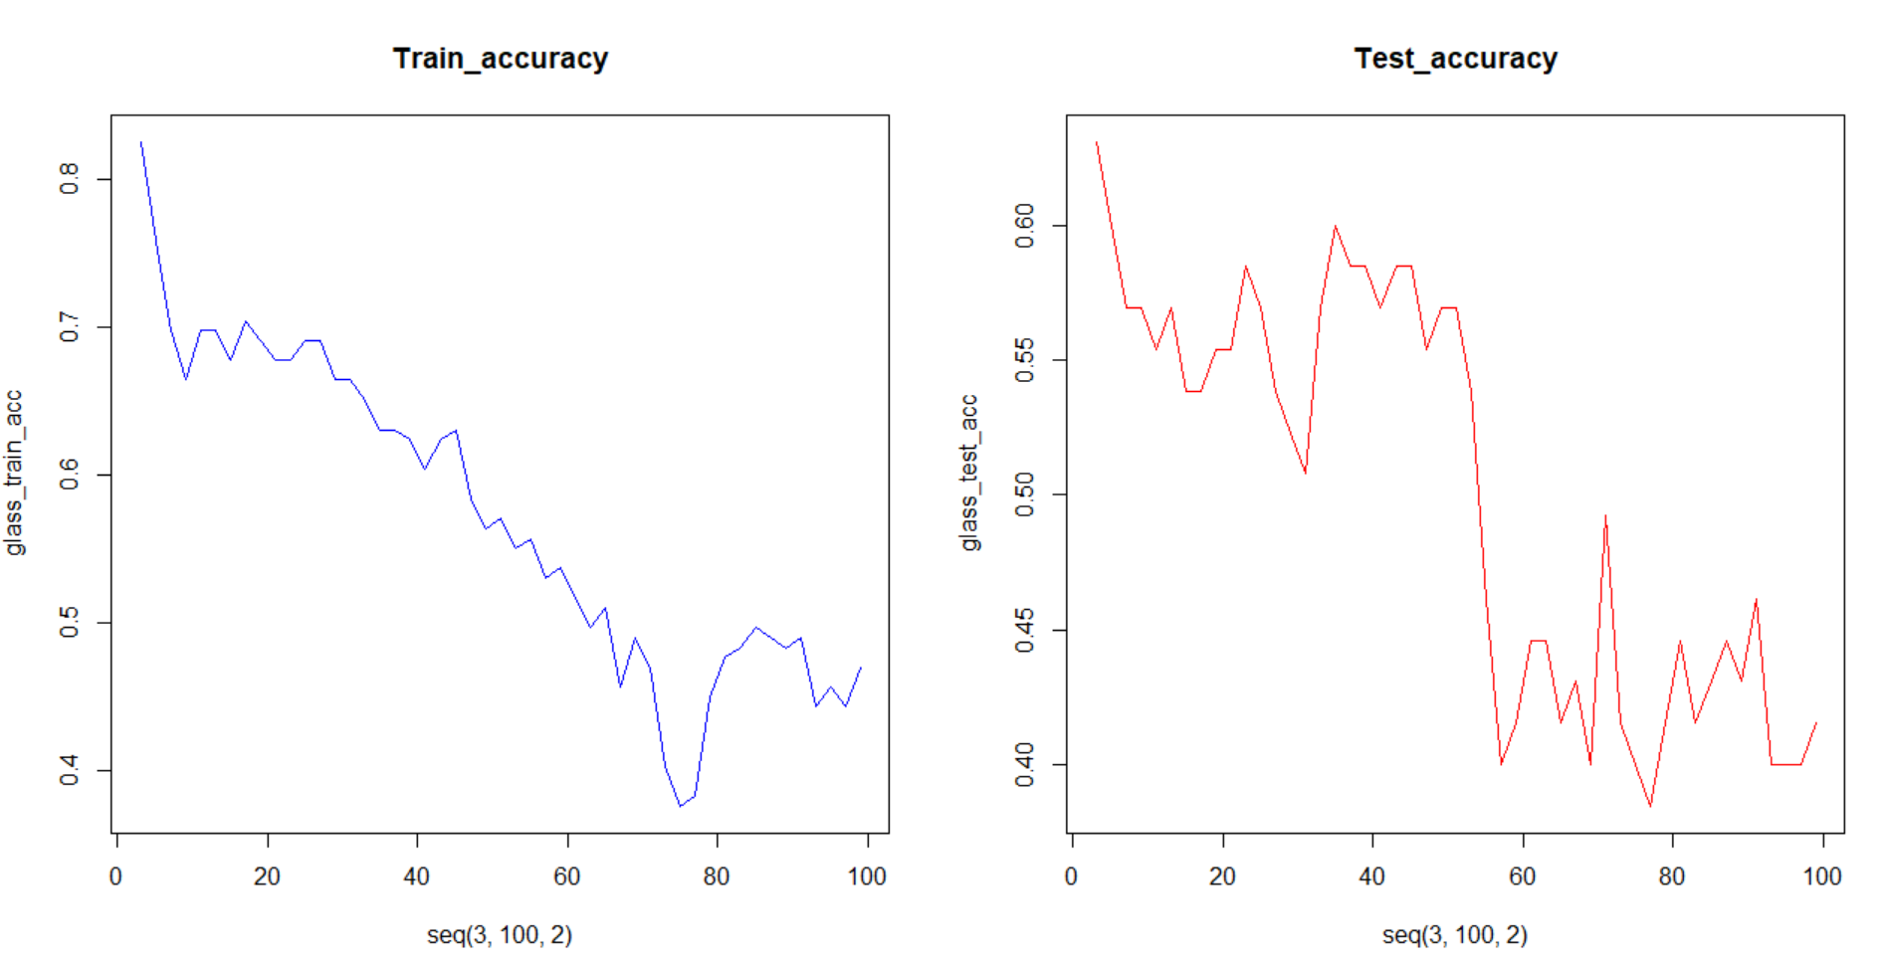

**Animal Zoo Classification Solution**

* By creating the function for finding the best K, I was able to find that the best value for K here would be 3.
* For k=3, Training accuracy = 95.71%. Testing Accuracy = 74.19%
* Following is the graph for different k values:

